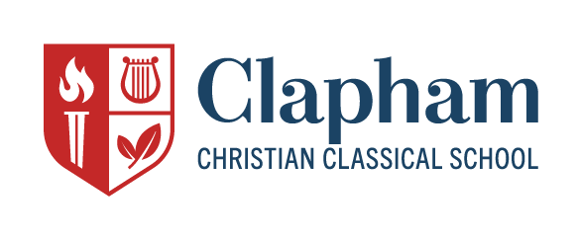
Job Description
Upper School Humanities Instructor
Full Time
Clapham School is seeking an instructor to teach Humanities in the Upper School (Class 9-12). Clapham School’s mission is to “inspire students with an education founded on a Christian worldview, informed by the classical tradition, and approached with diligence and joy.” Therefore, candidates must be willing to teach Humanities in a way that is inspiring, genuinely Christian, and distinctly classical. Classroom instruction should guide students in an approach to work characterized by joyful discovery and diligent attention to the disciplines of effective language learning.
The strongest candidates will have:
- A bachelor’s degree or higher in a humanities subject area.
- Background experience in teaching within the humanities, ideally with experience in classical education or Charlotte Mason’s philosophy of education.
- High competence in training students in the language arts, with attention to both spoken and written communication skills.
- Eagerness to contribute to aspects of school life and student culture with a spirit of service and a dedication to discipleship.
- Ability to interact professionally and cooperatively with parents and members of the school community.
- A commitment to learning the school’s unique philosophy of education and applying it to foreign language instruction.
- Demonstrated Christian maturity and involvement in a local church.

In addition to fulfilling normal teaching responsibilities, we are looking for a candidate who is eager to learn from and interact with other teachers and who would aim to build a thriving Upper School program in a way that is consistent with our unique pedagogy. To read more about our school and philosophy of education, please see our website (www.claphamschool.org).
Interested candidates should send a resume and cover letter to the Head of School, Kolby Atchison, KAtchison@claphamschool.org.

